W

WHITE WATER WEEKENDS



Site Plan

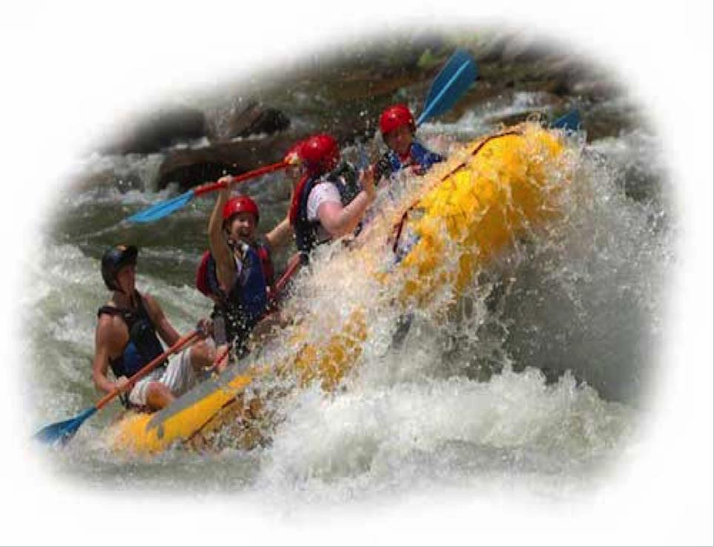

Sydney Hall WDD100-12

# Overview

## Site Purpose

The purpose of my site is to promote the activity of rafting. It should get people interested in the activity. Customers will be able to get information on certain rivers and be able to book trips if they want to get out for a few days.

## Target Audience

The target customers are those who try to get out on an adventure. We provide 3-6 day trips allowing our customers to get away from the stress of daily life for a little bit and enjoy themselves. They can be customers who have never rafted or those who have rafted their whole lives. We don't care we just want people to have fun.

# Branding

## Website Logo



Color Palette

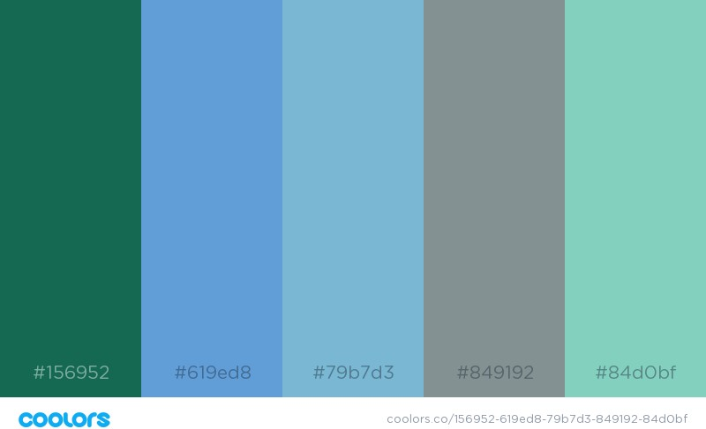

|  |  |  |  |  |
| --- | --- | --- | --- | --- |
| **Primary** | **Secondary** | **Accent** | **Accent** | **Accent** |
| #849192 | #84d0bf | #156952 | #619ed8 | #79b7d3 |

# Typography

I chose the fonts Josefin Sans, Arvo, and Pacifico. I feel that it gives a somewhat classic look while also being a little different. It*’*s not too crazy for some customers and it looks nice.

**+Heading Font**

***ABCDEFGHIJKLMNOPQRSTUVWXYZ***

***abcdefghijklmnopqrstuvwxyz 1234567890!@#$%^&*()_+***

**This is my Sample Heading**

## Body Copy Font

ABCDEFGHIJKLMNOPQRSTUVWXYZ

abcdefghijklmnopqrstuvwxyz 1234567890!@#$%^&*()_+

This is an example of my sample paragraph. It will show the color, size and style of a paragraph in my website.

# Navigation

## Main Navigation

When the link is normal then the background will be my secondary color and the lettering will be my primary color. You can see this is demonstrated in the link titled White Water Guides. When the link is hovered on and active the background will be my primary color and the lettering will be my secondary coloring. You can see this being displayed on the link titled Home. If a link has been visited then the background will be my secondary color and the lettering will be my dark green accent and underlined. You can see this being displayed on the link titled White Water Rivers.

|  |  |  |
| --- | --- | --- |
| Home | Rates and Dates | Rivers |

Link:normal : #84d0bf

Link:hover : #849192

# Layout



Home

Rivers

Rates and Dates

## Site Map

**Wireframes**



